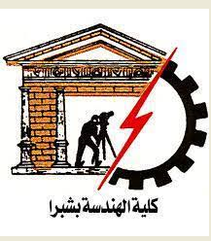

Name: Abdelrahman Rabea Mohammed Megawry

Group: 4

Sec: 19

ID : 426

Topic: Artificial Intelligence

**Github Link**:

**Github Page (published Website):**

**Application Brief:**

1. AI doesn’t get tired and wear out easily

Artificial Intelligence and the science of robotics is used in mining and other fuel exploration processes. These complex machines help to explore the ocean floor and overcome human limitations.

Due to the programming of the robots, they can perform a more laborious task with extra hard work and with greater responsibility. Moreover, they do not wear out easily232

#### 2.Repetitive jobs

The same old task, a task that doesn’t add value is of no use. Also, repetitive jobs are monotonous in nature and can be carried out with the help of machine intelligence. Machines think faster than humans and can perform various functions at the same time.

It can be employed to carry out dangerous tasks and its parameters are adjusted. This is not possible with humans as their speed and time can’t be calculated on the basis of parameters.

**LINKS of page titles:**

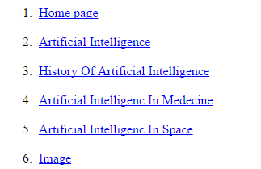

**SCREENSHOTS:**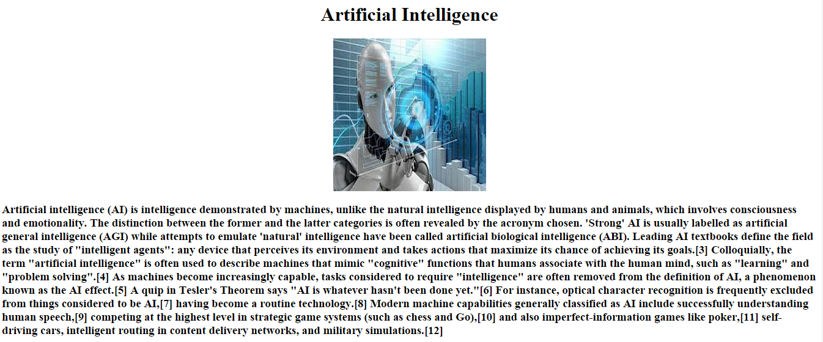

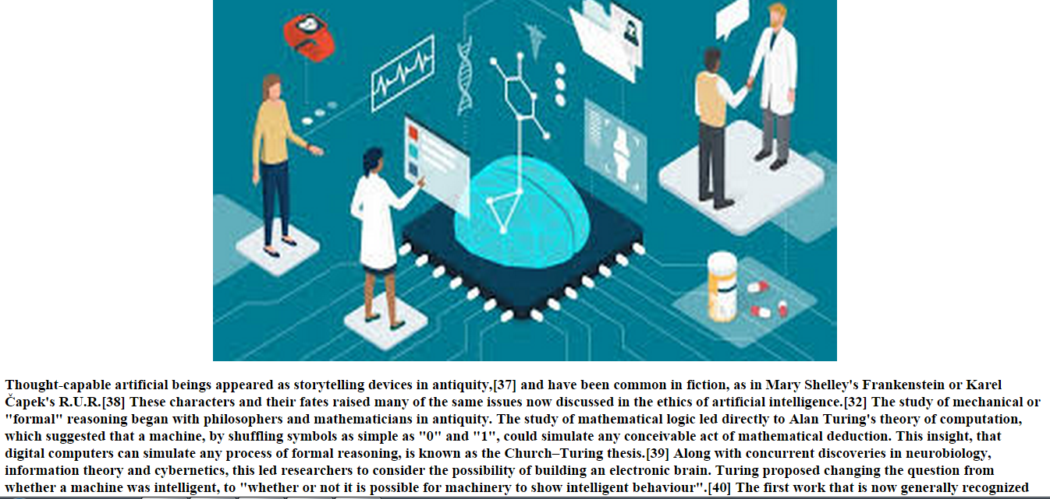

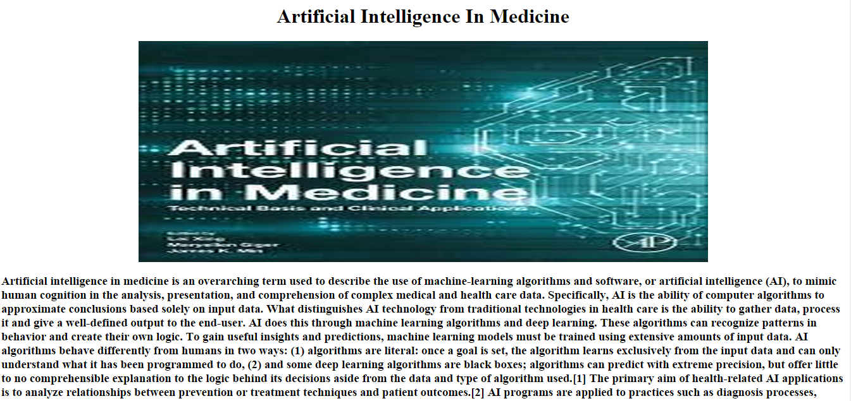

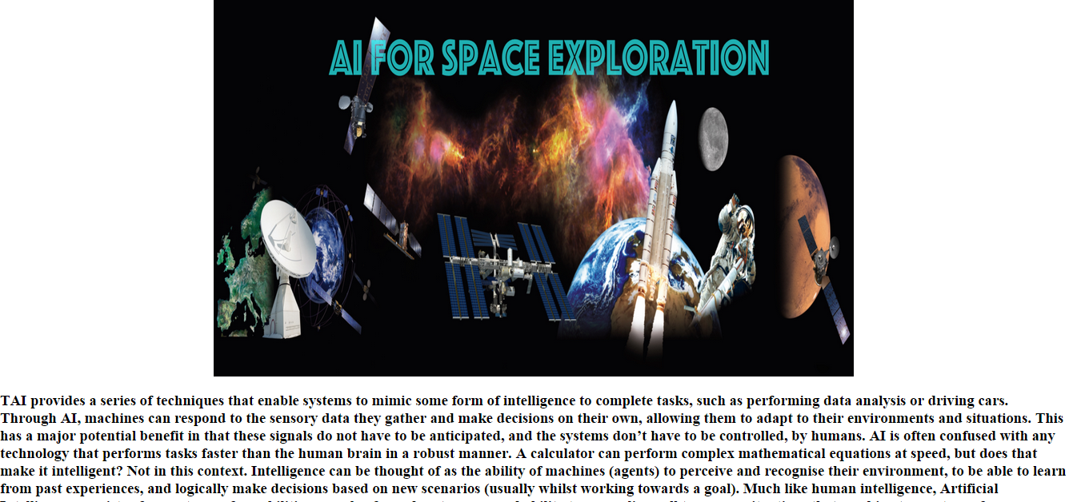

**Source Code:**

